Code change
Source/ZNA.UW/ZNA.UW.BLL/Analysis/Multiline/LossHistoryBLL/LossHistorySX.cs(message is added) line 4276
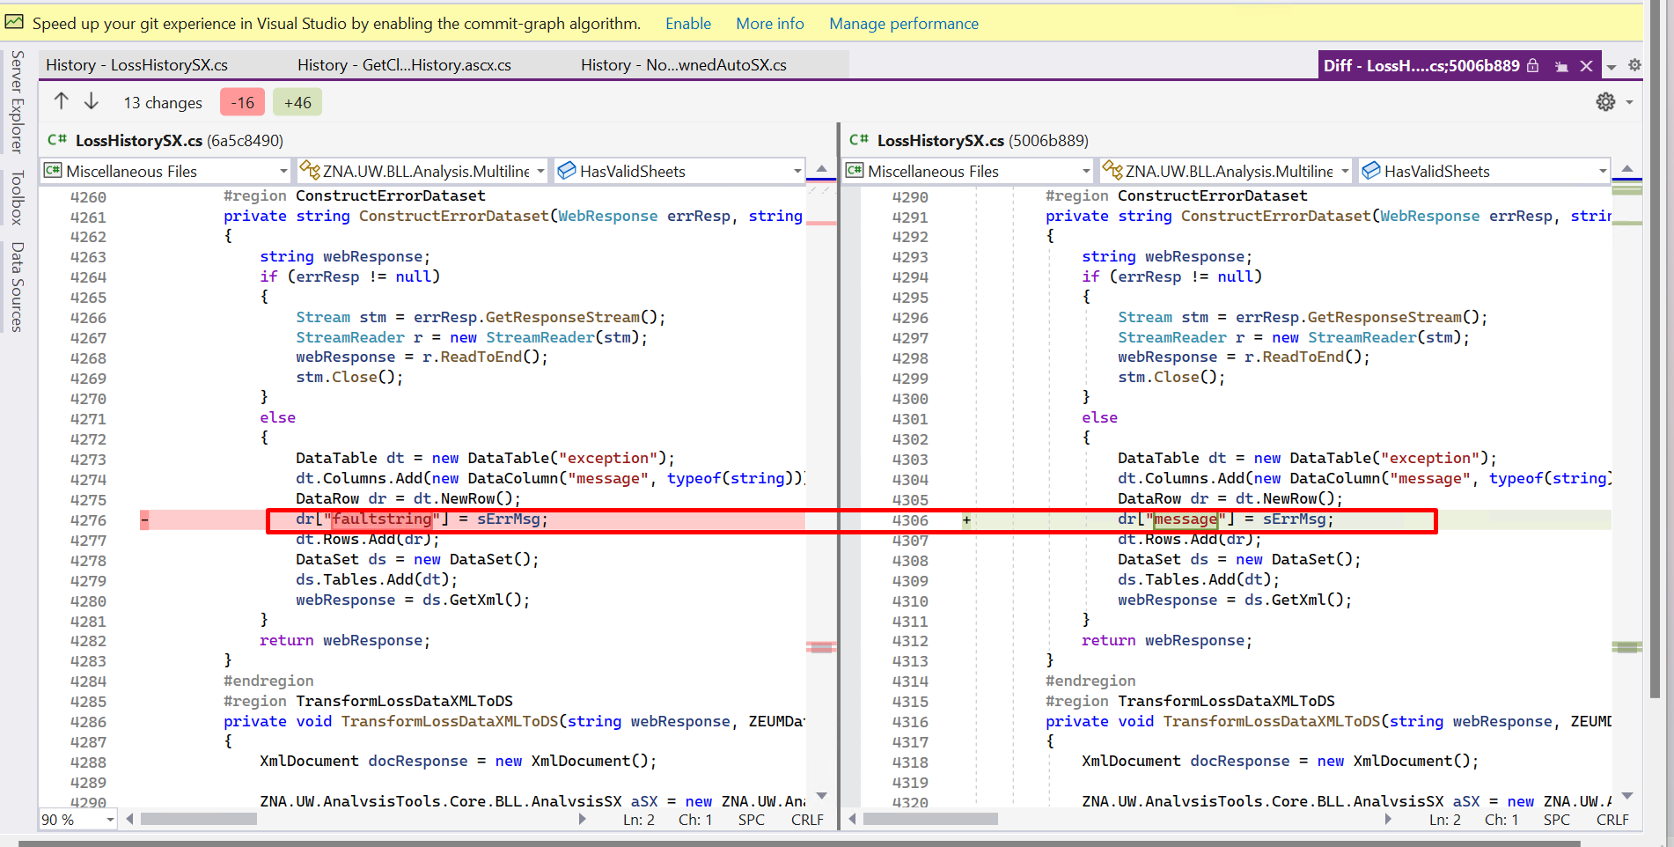

Source/ZNA.UW/DAL/Analysis/AUTO/RiskSelectionPricingDA.cs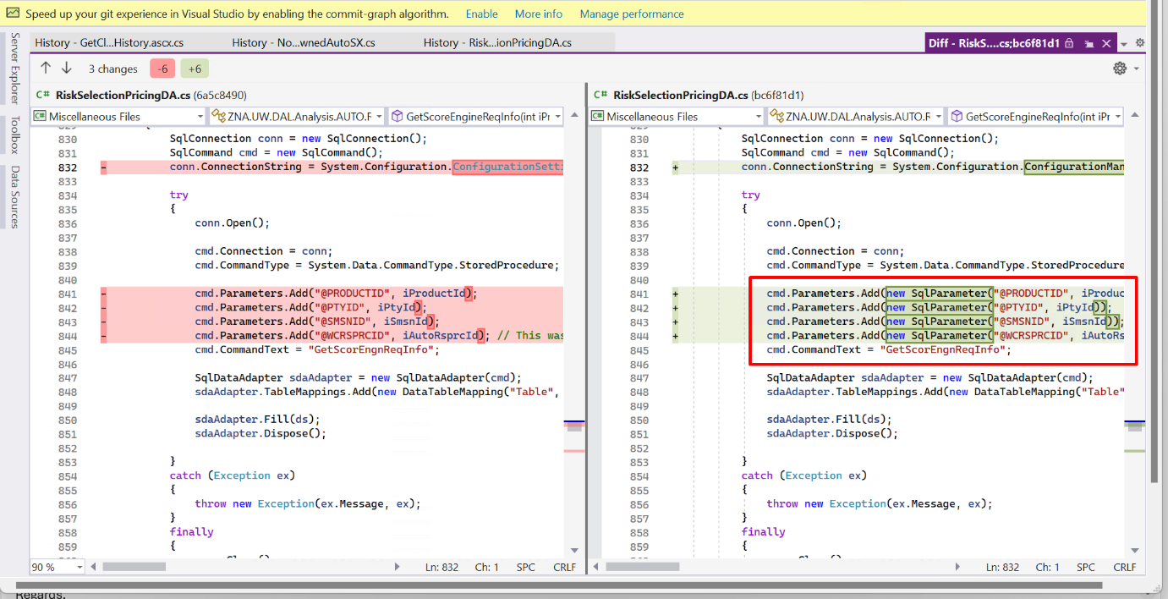
Source/ZNA.UW/DAL/Analysis/WC/RiskSelectionPricingDA.cs
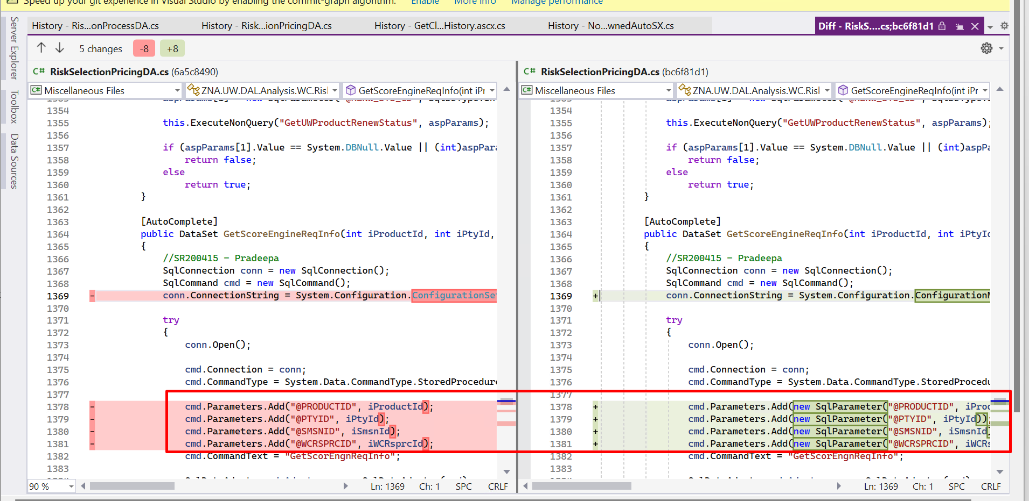
Source/ZNA.UW.AnalysisTools/GLRSP/DAL/RiskSelectionProcessDA.cs
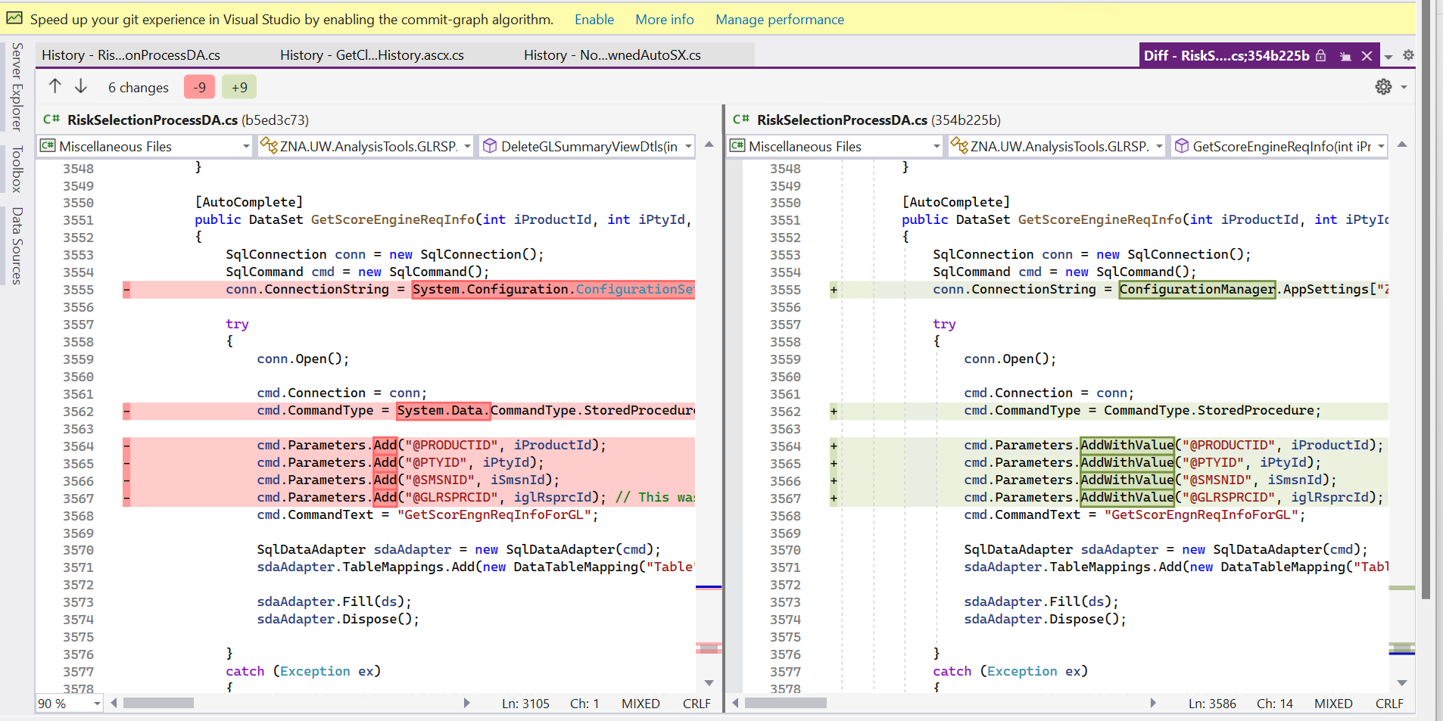
Source/ZNA.UW/DAL/Analysis/Multiline/RiskSelectionPricingDA.cs

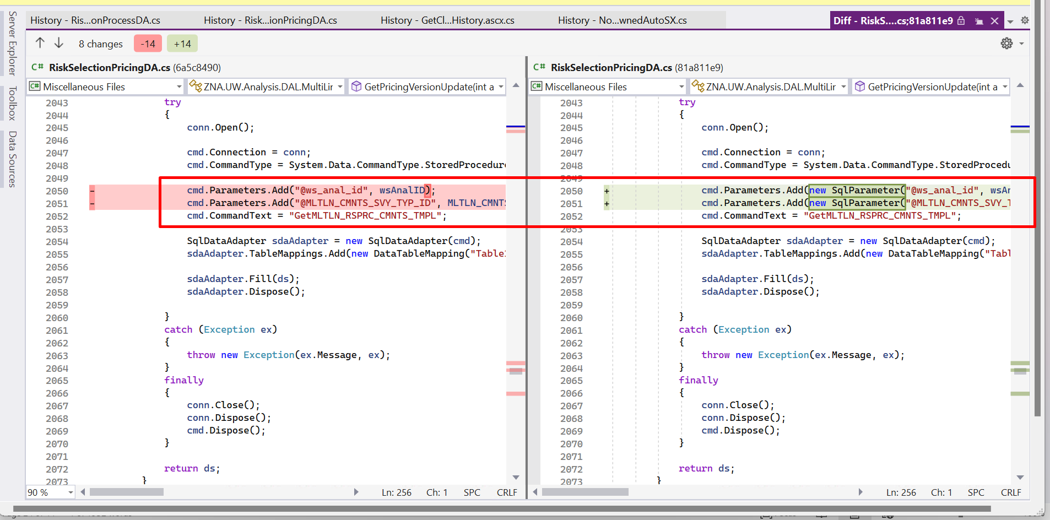

Source/ZNA.UW.AnalysisTools/GLRSP/Web/StepControls/ControlsUserControls/ControlsTabControls/SurveyControl.ascx.c
